Project A – Poisson Equation
(APc2-3)

MECE 5397: Scientific Computing for Mechanical Engineers
Spring 2017
Mahshid Hadi
0870520

Submitted to:
Dr. Andrea Prosperetti
Dr. Amit Amritkar

Discretization of Problem:

The problem is discretized using finite difference method. The following is the two dimensional Poisson equation:

$$\frac{∂^{2}u}{∂x^{2}}+\frac{∂^{2}u}{∂y^{2}}=-F(x,y)$$

The function on the right hand side of the stated Poisson equation is:

$$F\left(x,y\right)=\sin\left[π\frac{x-a_{x}}{b_{x}-a_{x}}\right]\cos\left[\frac{π}{2}\left(2\frac{y-a_{y}}{b_{y}-a_{y}}+1\right)\right]$$

The domain of interest is described by:

$-π<x<π$ And $-π<y<π$

The boundary conditions represented below have been simplified using available data from the problem statement:

Bottom: -pi*(by+pi)^2+((x-ax)/(bx-ax)).*(-(by+pi)^2+pi*(by+pi)^2)
Right: y.*(by-y).^2
Left: ((by-y).^2).*cos(pi*y/by)

The Neumann condition on the right side of the rectangle of interest:

$${\left.\frac{ ∂u}{∂x}\right|}_{x=π}=0$$

The Taylor series expansion (shown below) has been applied to obtain a two dimensional computational grid. The representation of the grid obtained by using the following equation is shown in figure 1.

$$\frac{u_{i-1,j}-2u_{i,j}+u_{i+1,j}}{∆x^{2}}+\frac{u_{i,j-1}-2u_{i,j}+u_{i,j+1}}{∆y^{2}}= f_{i,j}$$

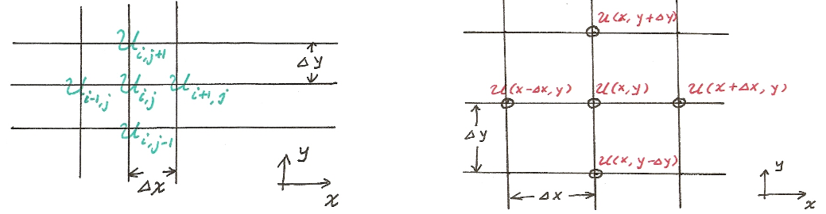
Figure 1: Visualization of the equation.

The discretized equation necessary for computation of the inner nodes is :

$$u_{i,j}=\frac{-1}{\left(2/∆x^{2}+2/∆y^{2}\right)}\left(-F\left(x_{i},y_{j}\right)-\frac{1}{∆x^{2}}u_{i-1,j}-\frac{1}{∆x^{2}}u_{i+1,j}-\frac{1}{∆y^{2}}u_{i,j-1}-\frac{1}{∆y^{2}}u_{i,j+1}\right)$$

Representation of the solution grid for the unknowns for the given problem is shown below

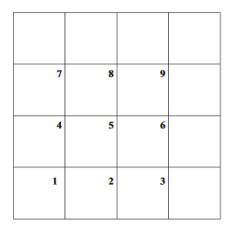
Figure 2: Discretization grids for the Problem.

The Dirichlet conditions are placed on the right, top and bottom of the square.

The Neumann condition has been implemented using the technique of ghost nodes.

$$\frac{u_{n+1}-u_{n-1}}{2h}=v$$

The method provides for better convergent solution.

Since $v=0$ for the given problem,

$$u_{n+1}=u_{n-1}$$

$u_{n-1}$ $u_{n}$ $u_{n+1}$

The above representation of the ghost nodes for the Neumann condition has been used to obtain the following equation applicable only at the specified boundary condition.

$$u_{i,j}=\frac{-1}{\left(2/∆x^{2}+2/∆y^{2}\right)}\left(-F\left(x_{i},y_{j}\right)-\frac{2}{∆x^{2}}u_{i-1,j}-\frac{1}{∆y^{2}}u_{i,j-1}-\frac{1}{∆y^{2}}u_{i,j+1}\right)$$

Description of algorithm:

The algorithms to be used for this report to analyze a poisson equation will be the Gauss-Sidel and successive over relaxation (SOR) methods. These algorithms provide highly accurate solutions using iterative trial and correction process.

Gausseidel:
$$x_{i}^{k+1}=\frac{1}{a_{ii}}\left(b_{i}-\sum_{j=1}^{n}{a_{ij}}x_{j}^{k+1}-\sum_{j+1}^{n}{a_{ij}}x_{j}^{k}\right)$$

Successice over relaxation (SOR):
$$x_{i}^{k+1}=\left(1-ω\right)x_{i}^{k}+ω\frac{1}{a_{ii}}\left(b_{i}-\sum_{j=1}^{n}{a_{ij}}x_{j}^{k+1}-\sum_{j+1}^{n}{a_{ij}}x_{j}^{k}\right)$$

Both of these methods provide a stable convergence to a solution with a near negligible error. The main difference between these two methods is the speed in which they converge to the solution.

Results:

The following two figures are a visual representation of the poisson solution. First is the form of surface plot and the second contour plot. The x and y axis show the two-dimensional space and z axis shows the magnitude of the respective positions.

Figure 3: Poisson Surface Solution
Figure 4: Poisson Contour Solution

A comparison of Gauss-Sidel and the (SOR) used to solve Poisson’s equation are shown in the tables and graph below.

Table 1: Gauss-Sidel Data Table
Gauss-Sidel
Node Number | Iterations | Time
10x10 | 100 | 0.420141
20x20 | 400 | 0.226697
30x30 | 900 | 0.248522
40x40 | 1600 | 0.284394
50x50 | 2500 | 0.537026
60x60 | 3600 | 1.090105
70x70 | 4900 | 1.905537
80x80 | 6400 | 3.062516
90x90 | 8100 | 5.261761
100x100 | 10000 | 6.765671
150x150 | 22500 | 32.198803
200x200 | 40000 | 99.060047

Table 2: SOR Data Table
SOR (omega =1.5)
Node Number | Iteration | Time
10x10 | 100 | 0.260307
20x20 | 400 | 0.151749
30x30 | 900 | 0.211106
40x40 | 1600 | 0.19638
50x50 | 2500 | 0.230696
60x60 | 3600 | 0.535635
70x70 | 4900 | 0.854478
80x80 | 6400 | 1.355759
90x90 | 8100 | 2.342933
100x100 | 10000 | 3.024314
150x150 | 22500 | 14.983901
200x200 | 40000 | 44.278117

Figure 5 : Comparison of Solver Performance

Grid Independence:

By observing the graphs for different nodes entered, it is clear that a drastic change does not occur. It is through this observation that grid independence is proven.

Verification:

The maximum of the row containing Neumann condition was found for each number of grids utilized. The maximum value was same for all of the grids used meaning the solution was convergent and validated.

References:

http://www.public.asu.edu/~hhuang38/pde_slides_numerical_laplace.pdf
http://www4.ncsu.edu/~zhilin/TEACHING/MA402/chapt5.pdf

